**Name: Shamjad Mazood Nazer**

**Roll No: 36**

**Batch: R-MCA B**

**Date: 08-04-2022**

**ADVANCED DATABASE MANAGEMENT SYSTEM LAB**

**Experiment No.: 2**

**Aim**

To familiarize with selecting data from single table.

**Question**

Using lab cycle 1, perform the questions below:

1. List all data from table deposit
2. List all data from borrow
3. List all data from customer
4. List all data from branch
5. Give account no and amount of deposit
6. Give customer name and account no of depositors
7. Give name of customers
8. Give name of branches
9. Give name of borrows
10. Give names of customer living in city Nagpur
11. Give names of depositors having amount greater than 4000
12. Give account date of Anil
13. Give name of all branches located in Bombay
14. Give name of borrower having loan number l205
15. Give names of depositors having account at VRCE
16. Give names of all branched located in city Delhi
17. Give name of the customers who opened account date ‘1-12-96’
18. Give account no and deposit amount of customers having account opened between dates ‘1-12-96’ and ‘1-5-96’
19. Give name of the city where branch KAROLBAGH is located
20. Give details of customer ANIL

**Procedure & Output Screenshot**

1. SELECT * FROM BRANCH;

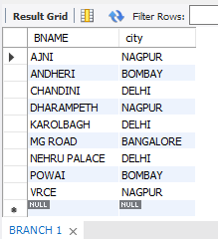

1. SELECT * FROM CUSTOMER;

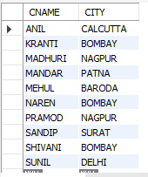

1. SELECT * FROM DEPOSIT;

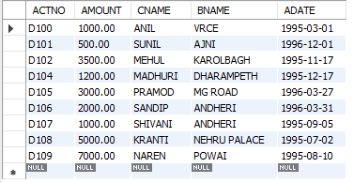

1. SELECT * FROM BORROW;

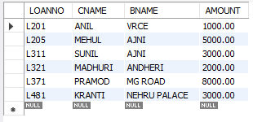

1. SELECT ACTNO, AMOUNT FROM DEPOSIT;

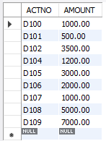

1. SELECT CNAME, ACTNO FROM DEPOSIT;

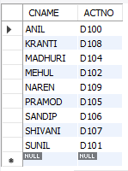

1. SELECT CNAME FROM CUSTOMER;

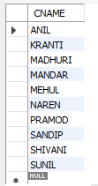

1. SELECT BNAME FROM BRANCH;

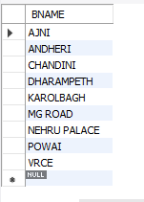

1. SELECT CNAME FROM BORROW;

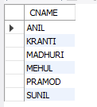

1. SELECT CNAME FROM CUSTOMER WHERE CITY = 'NAGPUR';

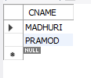

1. SELECT CNAME FROM DEPOSIT WHERE AMOUNT > 4000;

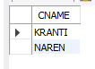

1. SELECT CNAME, ADATE FROM DEPOSIT WHERE CNAME = 'ANIL';



1. SELECT BNAME FROM BRANCH WHERE CITY = "BOMBAY";

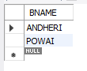

1. SELECT CNAME FROM BORROW WHERE LOANNO = "L205";



1. SELECT CNAME FROM DEPOSIT WHERE BNAME = 'VRCE';



1. SELECT BNAME FROM BRANCH WHERE CITY = "DELHI";

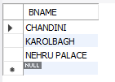

1. SELECT CNAME FROM DEPOSIT WHERE ADATE = '1996-12-01';



1. SELECT ACTNO, AMOUNT FROM DEPOSIT WHERE ADATE BETWEEN '1996-05-01' AND '1996-12-01';

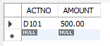

1. SELECT CITY FROM BRANCH WHERE BNAME = "KAROLBAGH";



1. SELECT * FROM CUSTOMER JOIN BORROW ON CUSTOMER.CNAME=BORROW.CNAME JOIN DEPOSIT ON DEPOSIT.CNAME=BORROW.CNAME WHERE CUSTOMER.CNAME = 'ANIL';

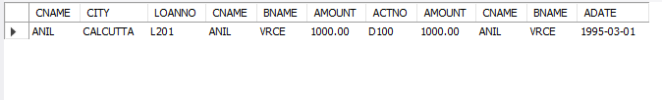

**Experiment No.: 3**

**Aim**

To familiarize DDL Commands- ALTER, DROP, TRUNCATE, RENAME

**Question**

1. Create a table emp with attributes empno number (4) as primary key, ename char (10), hiredate, salary, commission.

Insert 5 rows of data

|  |  |  |  |  |
| --- | --- | --- | --- | --- |
| 101 | Ramesh | 17-Jan  1980 | 5000 |  |
| 102 | Ajay | 05-Jul  1985 | 5000 | 500 |
| 103 | Ravi | 12-Aug  1981 | 1500 |  |
| 104 | Nikesh | 03-Mar  1983 | 3000 | 700 |
| 105 | Ravi | 05-jul  1985 | 3000 |  |

1. Modifying the structure of tables
2. Add new columns: sal number (7,2)
3. Dropping a column from a table: sal
4. Modifying existing column: ename varchar2(15)
5. Renaming the tables: emp to emp1
6. truncating the tables: emp1
7. Destroying tables: emp
8. Create a table stud with sname varchar2(20) primary key, rollno number (10) not null, dob date not null
9. Create a table student as regno number (6), mark number (3) check constraint (mark >=0 and mark <=100));
10. Create a table cust with (custid number (6) constraint unique, name char (10)

**Procedure & Output Screenshot**

1. CREATE DATABASE EMP_LAB_CYCLE_3;

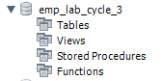

USE emp_lab_cycle_3;



CREATE TABLE EMP(

EMPNO INT(4) PRIMARY KEY,

ENAME VARCHAR(10),

HIREDATE DATE,

SALARY INT,

COMMISSION INT

);

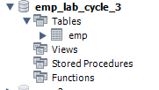

INSERT INTO EMP(EMPNO, ENAME, HIREDATE, SALARY, COMMISSION) VALUES('101', 'RAMESH', '1980-01-17', 5000, NULL);

INSERT INTO EMP(EMPNO, ENAME, HIREDATE, SALARY, COMMISSION) VALUES('102', 'AJAY', '1985-07-05', 5000, 500);

INSERT INTO EMP(EMPNO, ENAME, HIREDATE, SALARY, COMMISSION) VALUES('103', 'RAVI', '1981-08-12', 1500, NULL);

INSERT INTO EMP(EMPNO, ENAME, HIREDATE, SALARY, COMMISSION) VALUES('104', 'NIKESH', '1983-03-03', 3000, 700);

INSERT INTO EMP(EMPNO, ENAME, HIREDATE, SALARY, COMMISSION) VALUES('105', 'RAVI', '1985-07-05', 3000, NULL);

SELECT * FROM EMP;

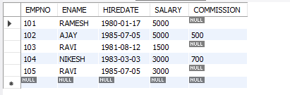

1. a. ALTER TABLE EMP ADD SAL FLOAT(7,2);



SELECT * FROM EMP;

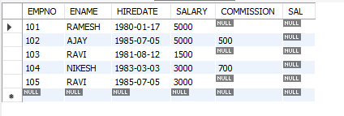

b. ALTER TABLE EMP DROP SAL;



SELECT * FROM EMP;

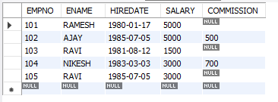

c. ALTER TABLE EMP MODIFY ENAME VARCHAR(15);



d. RENAME table EMP to EMP1;



e. TRUNCATE TABLE EMP1;



f. DROP TABLE EMP1;

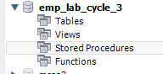

1. CREATE TABLE STUD(

SNAME VARCHAR(20) PRIMARY KEY,

ROLLNO INT NOT NULL,

DOB DATE NOT NULL

);

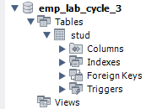

4. CREATE TABLE STUDENT(

ROLLNO INT,

MARK INT CHECK(MARK>=0 AND MARK<=100)

);

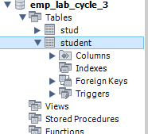

1. CREATE TABLE CUST(

CUSTID INT PRIMARY KEY,

NAME VARCHAR(10)

);

